

Product Requirements Document

VUE Go-To-Market (GTM)
Document #999-00001-B_RADAR_ONLY
MS Word Version 2.1

Issued PDF timestamp: 2025-05-01-0600 PT USA

Spoke Safety Inc Confidential

Table of Contents
1 Document Purpose 4
1.1 Requirement Identifiers 4
2 Introduction 5
2.1 Hardware Block Diagram 6
2.2 Principle Functionality Explained 7
2.3 Key Component Candidates 9
3 Functional Requirements 10
3.1 Electrical Requirements (ELEC-###) 10
3.2 Mechanical Requirements (MECH-###) 10
3.3 Software Requirements (SOFT-###) 10
3.4 Interface Requirements (INTE-###) 10
4 Non-Functional Requirements 11
4.1 System Attributes Requirements (SYSA-###) 11
4.2 Project Management Requirements (PROJ-###) 11
4.3 Regulatory / Approbation Requirements (REGU-###) 11
4.4 Certifications Requirements (CERT-###) 11
5 Reference & Support Documents 12

Revision History
Version | Date | Author(s) | Notes
1.0 | 2025-01-31 | Blaze Sanders  Domenico Actis | - Initial document  - R&D hardware variants merged
1.1 | 2025-02-28 | Kevin Lieberman  Thomas Falls | - Requirement (rmt) ID data tags selected  - Software architecture touch points added
2.0 | 2025-03-04 | David Brodie  Jovan Zagajac  JP Brocket | - Restructure requirements into tables and clean up formatting  - Version exported to PDF for Contract  Manufacturers providing RRP EMS quote
2.1 | 2025-05-01 | Blaze Sanders  JP Brocket | - Add detailed RADAR_MODULE rqmts  - Link section 3.0 & 4.0 to SQLite database
Table 0 – Document version history
Abbreviations & Terminology
Term | Definition
Alert | Inform user about an impending risk (Mid-level importance user message)
BSP | Board Support Package: Allows OS to communicate with low level hardware
CM | Contract Manufacture: Term for company that manufacture products
DT / TM | Deutsche Telekom/T-Mobile: TM shall not be used alone, it’s too similar to ™
EMS | Electronic Manufacturing Services: A CM that designs, tests, distributes, and provides return/repair services for electronic components and assemblies for original equipment manufacturers (OEMs)
GTM | Go-to-Market: Product Spoke plans to sell as its 1st stock keeping unit (SKU)
HUB™ | The Spoke Cloud: AWS servers running EC2 instances
Information | Inform user about upcoming risks (Least important user message)
IPC | Inter-Processor Communication: Communication bus for CPU data exchange
DMIPS | Dhrystone Millions of Instructions Per Seconds: A rough benchmark of CPU speed. FLOPS is a more modern benchmark; however, less common in embedded devices.
POST | Power On Self-Test: With standard computer bootup LEDs and/or sounds
SCA | The Spoke Companion App: iOS and Android app that pairs to VUE
TCI | Test and Communication Interface (required by OmniAir)
TTI | Time to Incident: Time until collision between bicycle and car
VRU | Vulnerable Road User: Bicycle, motorcycle, or scooter rider or etc
VRU2X™ | VRU2XTM is an enabler for the VUE™ and connects riders to the broader ecosystem including cars and infrastructure. VRU2X™ fuses sensor information from bikes (radar), cars (position, speed, heading) and infrastructure information (road surface, traffic, intersection signal, bike lane, etc.) which puts you in control of what you see and allows others to see you.
Warn | Inform user about an imminent risk (Most important user message)
Table 1 – Local document acronyms and initialisms

Document Purpose
This document defines the requirements for VUE™, Spoke’s (GTM) portfolio offering.
The full Spoke Safety platform consists of the following three (3) interconnected subsystems:
- The VUE™, embedded device, which mounts to bicycle seat-posts.
- The Spoke Companion™ App (SCA), iOS & Android smart phone app that connects to VUE.
- The Spoke HUB™, Spoke’s cloud solution for supporting VRU2X™.

Requirement Identifiers
Each requirement has a unique identifier according to the following structure: Domain-<Number>[Tag] (e.g. SYSA-001[QC] = System Attribute #1 regarding Quality Control).
Where Domain will be one of the following: CERT (certification), ELEC (electrical), MECH (mechanical), INTE (external interface), PROJ (project management), REGU (regulatory), SOFT (software), SYSA (system attribute).
And where Tag may be one of the following short (< 10 characters preferred) tags to make database searching and filtering easier: Power, Interface, Strength, Bandwidth, Quantity, Cost, Location, Schedule, UX (User Experience), UI (User Interface), Color, Material, Sourcing, Safety, Security, API (Application Programing Interface), IPC (Inter-Processor Communication), Testing, Logs, QC (Quality Control), QA (Quality Assurance), OS (Operating System), OTA (Over The Air updates), V2X (short for C-V2X = Cellular Vehicle to Everything), Process, Performance, RADAR
All units shall be metric International System of Units (SI), with imperial units added only for convenience for weight. If a numerical value is not labeled, assume SI units are being used.
In expressing requirements, the following terminology will be used:
- shall means “is required to” and thus used to define exact must have requirements
- will means “it is true that” and thus used in statements of fact
- may means “is permitted to” and thus is used to allow flexibility to save time or money
- note is used for informational context and is not required to implement the specification

Introduction

The VUE™ will be attached to a bike seat post as shown in the following diagram.

ß Left 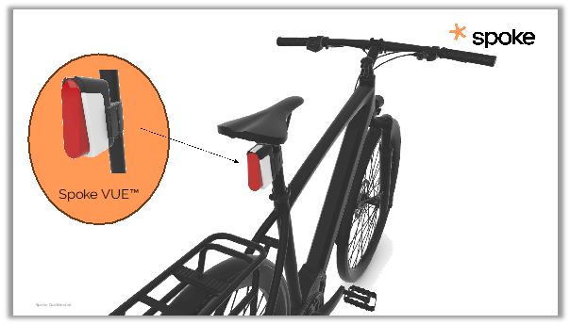 Right à
Figure 1 – VUE hardware X, Y, Z right hand rule axis definition with respect to a human seating on a bike
X = Width (+Right & -Left), Y= Depth (+Ahead & -Behind), and Z = Height (+Up & -Down)

As can be seen the VUE™ is effectively a bike light. It supports also communication technologies like C-V2X to allow direct digital communication between bikes and cars to help drivers and cyclists be aware of each other.

Hardware Block Diagram
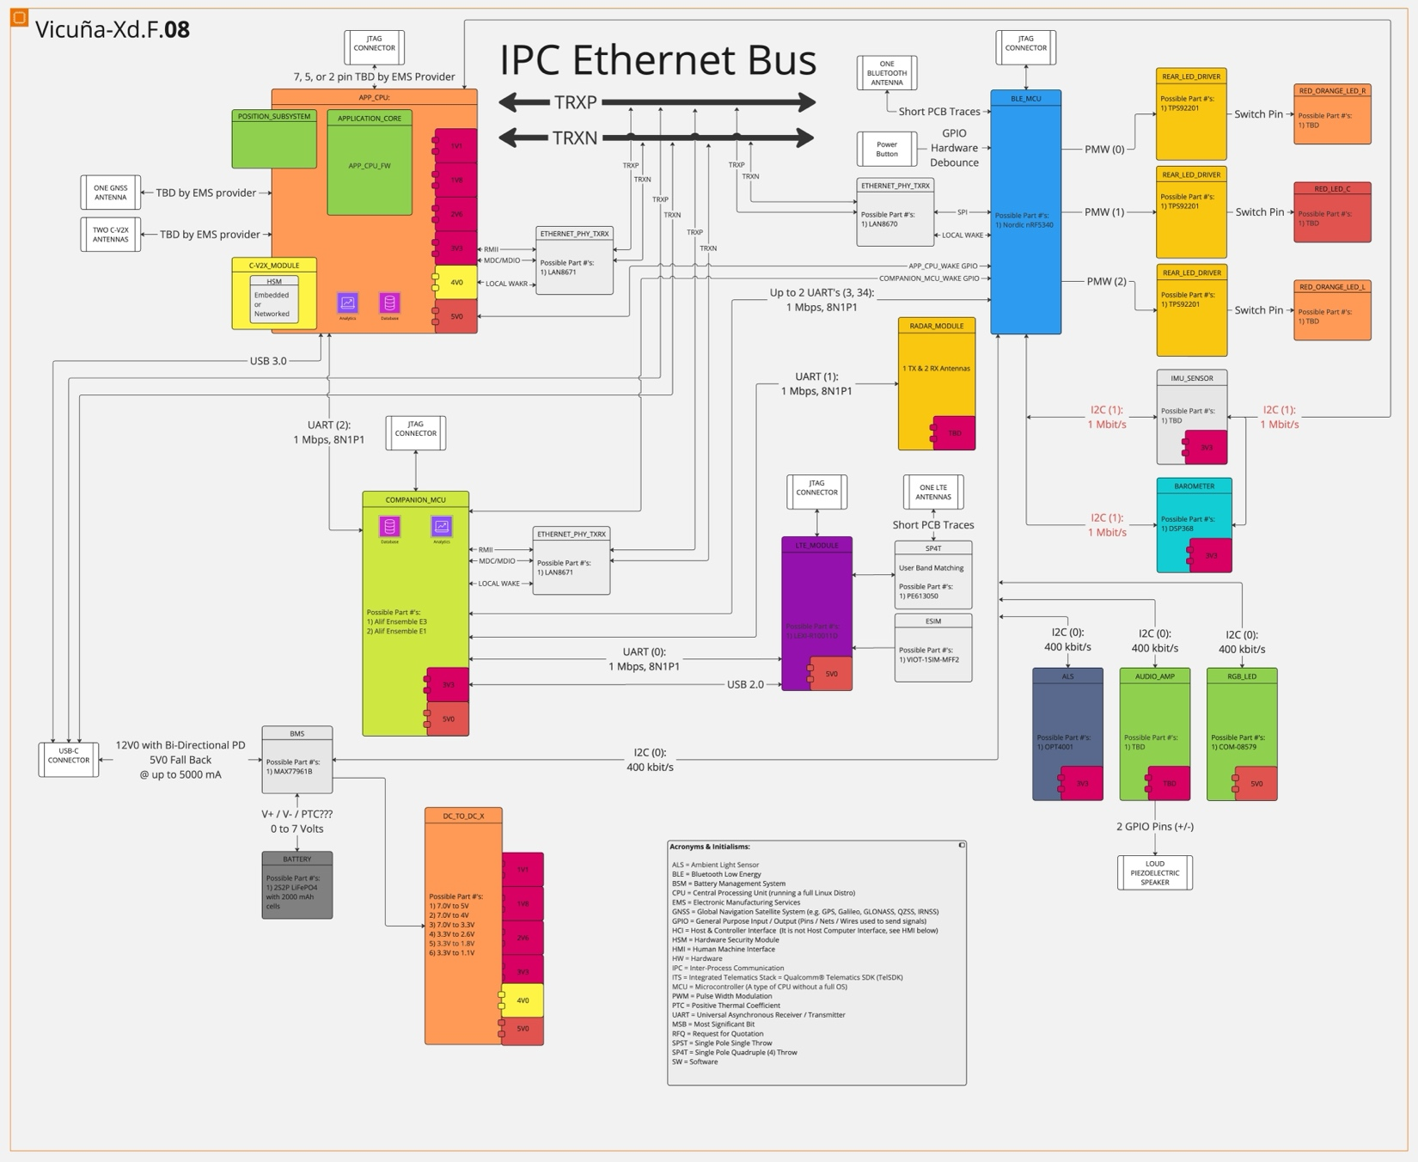
Figure 0 – Possible high-level architecture with UARTs and IPC Single Pair Ethernet bus.
See 999_00001_A_Figure_0.jpg for higher resolution image.

Principle Functionality Explained
The following paragraphs and image provide a description of key aspects of the VUE as a preface to more fully understand the formal requirements in sections 3.0 and 4.0 below.
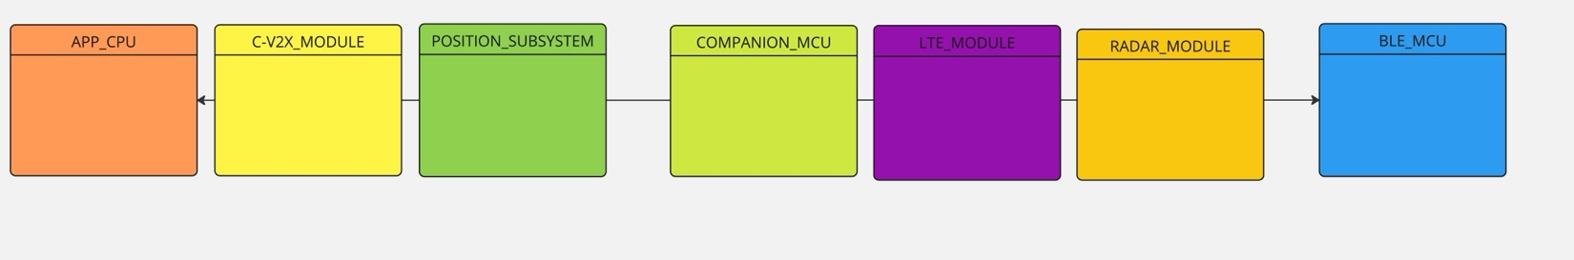
The VUE as targeted will have six (6) Central Processing Unit’s (CPU’s) and one (1) positioning system. Full functionality of the VUE requires all processors be running. The main application processor (APP_CPU) is the most powerful CPU on the VUE PCB and is required to process C-V2X data. A secondary application processor (COMPANION_MCU) will run core middleware functions like provisioning of the modem for the Mobile Network Operator interface (eSIM) and LTE signal strength determination and communicate directly with the RADAR_MODULE. The proposed architecture is conceived to allow for a structured powering down, of all processors (except for the Bluetooth Microcontroller (BLE_MCU)) to reduce overall power consumption and to increase the devices operation time; albeit with reduced functionality & features.
The BLE_MCU will take an active role in Over the Air (OTA) firmware updates released by Spoke Safety Inc in the coming years. Bluetooth is used to support connectivity to various devices including devices like heartrate monitors and wheel speed sensors used by cyclists, eternal bike lights, cycling computers, as well as for connecting the VUE to the Spoke Companion App (SCA) which provides both a UX during cycling as well as admin functions like configuring the VUE and managing software updates.
The 4G LTE radio (LTE_MODULE) is used almost exclusively for IoT functionality and to exchange messages with internet addresses. In addition to digital data connectivity the VUE will use RADAR technology to provide high-fidelity target tracking data (range, relative velocity, azimuth angle) to the Spoke VUE host system. Critically, the RADAR_MODULE shall ingest and utilize rider-motion data (including IMU data and ground speed) provided by the Spoke VUE host system via a dedicated bi-directional input /output interface. This internal fusion capability within the RADAR_MODULE is intended to significantly improve tracking accuracy, stability, and the rejection of false positives/negatives compared to modules relying solely on their own measurements. This will produce highly accurate target states and let system differentiate between direct collision threats, safely passing vehicles, and stationary objects, thereby minimizing nuisance alerts and maximizing rider trust.
Note that positioning accuracy (including position heading and speed) is key to the functionalities of the VUE. The GNSS provided by the C-V2X_MODULE hardware and POSITITON_SUBSYSTEM software shall be sufficient to pass the OmniAir certification of a minimum of 1.5 meters of precision. Which is required to have the VUE be a certified C-V2X device recognized by cars and support safety-critical risk assessment. To support this functionality the VUE will also utilize an IMU and a barometer (to measure sub-meter relative changes in elevation over short time periods). The VUE hardware platform must provide functions to provision the device for sending/receiving authentic C-V2X using SCMS certificates in the European Union and the FCC in the Unites States of America.
The proposed architectural concept also foresees an efficient inter-thread, inter-process, inter-processor communication (IPC) bus and shared resources, via lightweight efficient POSIX sockets and protocol families (like TCP based ZeroMQ) to ease the partitioning of functions across the different processors mentioned above. A minimum data rate of 1 Mbps should be sufficient for most operational scenarios (C-V2X, RADAR, LTE), and a maximum data rate of 10 Mbps should allow for a responsive system for large file transfers (e.g. < 4 seconds for a 5 MB file).
The USB-C port is used primarily for powering the VUE but will also support special functions detailed later in the document, for example the USB port must also interface to the so-called Test and Control Interface (TCI) used during OmniAir V2X certification [5] of the product or during the R&D phase to SSH into the VUE for diagnoses and maintenance.
The VUE will have a status LED which must support different colors and flashing patterns. In addition, the VUE has high-power LEDs users (e.g. brake and signal lights) used to attract the attention of other road.
The VUE can optionally be used in conjunction with an app or a bike computer to provide an UX on the handlebars. Some cyclists like to ride without a phone or bike computer, thus the VUE will include a loudspeaker doubling as an electric bike bell to be able to provide acoustic signals.
The VUE shall have an IMU to; determine changes in motion and orientation on the host bicycle, supporting risk assessment, and support theft & crash detection. Optionally VUE may have a barometer (with pressure and temperature sensor) to; determine ambient temperature/weather conditions, and track changes in elevation to support risk assessment. That said, EMS providers may propose other solutions / technology to provide reliable accurate elevation data.
Board functions must be presented to dependent application functions allocated to other processors. In these cases, the respective BSP must provide a proxy driver. The client of a proxy driver is abstracted from the implementation detail of the board function and its physical connection to any processor within the VUE. For example, a function in the APP_MCU must control an LED that is physically connected to the BLE_MCU using a proxy driver. The proxy driver must leverage the Inter-processor Communication to provide the board function.
Lastly the VUE hardware platform must support the authorization and authentication for access to persistent storage, dynamic storage, and processor operations. This may require implementation details like; incorporation of a Hardware Security Module (HSM) inside the POSITION_SUBSYSTEM, the removal of JTAG access after factory programming, and secure debug & secure shell features.

Key Component Candidates
Spoke is considering the following CPU components but intends to make the final selection in conjunction with the Contract Manufacturer (CM) providing the Electronic Manufacturing Services. We are requesting the potential supplier of EMS to price all alternatives as the cost and fit to overall requirements will be considered in the final component decisions.
- APP_CPU:
  - Option A: AutoTalks TEKTON3
    - e.g. Murata Type 2AN
  - Option B: NXP MIMX9352DVVXMAB
  - Option C: Internal to Qualcomm SA522M (Quadcore)
- C-V2X_MODULE:
  - Option A: AutoTalks SECTON3 + PLUTON2 chips or equivalent module
    - e.g. Murata Type 1YL
  - Option B: SA415M or SA515M
    - e.g. LAM-x800 / VMC-QSA515M
  - Option C: Internal to SA522M (Dualcore)
- LTE_MODULE:
  - Option A: UBlox LEXI-R10 Series
  - Option B: Any global 4G CAT-1 Bis
    - e.g. Telit Cinterion LE910Q1-WW module
  - Option C: Internal to SA522M (NRE to remove 5G , and run in 4G Cat-1 Bis mode)
- BLE_MCU: Nordic nRF5340
- RADAR_MODULE: Must pass bi-directional PRD requirements and concepts in section 2.2
- COMPANION_MCU: Alif Ensemble E3

Functional Requirements
Functional requirements define specific behavior or functions of the system that the end user specifically demands as basic facilities.

Electrical Requirements (ELEC-###)
ELEC-003[Power]: VUE shall operating for 15.0 hours in Reduced RADAR power mode.
ELEC-006[Power]: The VUE five (5) power modes (Nominal, IoT, Reduced RADAR, Anti-Tamper, and Deep Sleep (drawing <27 µA) shall be managed in the BLE_MCU, as defined in the Power Mode Matrix document 998-00001-A.
ELEC-031[RADAR]: VUE shall use a 2T3R RADAR_MODULE which contains 2 transmit antenna and 3 receive antennas to provide enhanced angular tracking.
ELEC-042[Power]: The RADAR_MODULE shall operate from a DC power source within a range of 3.00 to 7.00 Volts and 0.143 to 0.333 Amp, with a 60 second sliding average power consumption during active operation (including processing rider-motion data) of less than 1.00 Watts.

Mechanical Requirements (MECH-###)
MECH-007[Strength]: VUE shall have an ambient environment (e.g. in car truck or nominally on bike) operational temperature range of -10°C to 60°C, with all on PCB integrated circuit (IC’s), CPU's (e.g. BLE_MCU, APP_CPU, COMPANION_MCU), and X_MODULE's (e.g. RADAR_MODULE, LTE_MODULE, C-V2X_MODULE), and the POSITION_SUBSYSTEM rated for the Industrial range of -20°C to 85° C as defined by Maxim Integrated Products, Inc.
MECH-014[RADAR]: The RADAR_MODULE shall be compact and lightweight with maximum dimension of 40 H x 12 D x 30 W mm (See Figure 1 of 999-00001-A for (X, Y, Z) axis definition).

Software Requirements (SOFT-###)
SOFT-005[RADAR]: VUE shall interface with RADAR_MODULE as a black box via BSP API’s, which provide information on objects detected by the RADAR.
SOFT-006[RADAR]: The RADAR_MODULE shall provide the coarse size of detected objects, and label them with at least one the four following enum values: Large Vehicle, Passenger Vehicle, Motorized Two Wheel, or Bicycle.
SOFT-012[RADAR]: VUE host system shall read the following variables from the RADAR_MODULE: relative distance (m), relative velocity (m/s), relative angular horizontal direction (degree), Power Draw (Watts), and On/Off State (Boolean), RADAR_MODULE operational states (enum) in read only mode to identify and track with non-swapping UUID’s at least eight (8) objects.
Note: Negative relative velocities shall not be filtered out on the data presented to the UART, so that Spoke can perform its own filtering in the COMPANION_MCU. The COMPANION_MCU may allow post processing of RADAR images to enable Constant False Alarm Rate (CFAR) detection, Dynamic Programming (DP) algorithms, Clustering algorithms, and Kalman filtering. See SOFT-024 for ""Operational State"" details.
SOFT-016[RADAR]: Target data (defined in SOFT-012) sent to the host system of VUE shall remain stable (less then 2% jitter in range ever 200 ms) during typical cyclist maneuvers (e.g. cornering at up to 20.0 degrees lean, acceleration/deceleration up to ±2.00 m/s²) when provided with accurate rider-motion data.
SOFT-017[Performance]: VUE shall transmit data out of the BLE_MCU antenna within 25 milliseconds (ms) of the RADAR_MODULE, C-V2X_MODULE, or LTE_MODULE outputting a risk object on its communication interface. The time between a real-life event occurrence and corresponding target data availability at the output interface shall be less than 50 milliseconds.
SOFT-021[RADAR]: The RADAR_MODULE shall utilize the ingested rider-motion data within its internal algorithms to: Perform motion compensation for improved target state estimation (absolute/relative position and velocity); Reliably discriminate between moving and stationary objects, significantly reducing false positives from stationary infrastructure (signs, guardrails, parked cars) when the bicycle is in motion; Improve tracking stability and accuracy during cyclist maneuvers (e.g., leaning, turning, accelerating, decelerating); Reduce the occurrence of false negatives and ghost targets.
SOFT-022[RADAR]: Utilizing its RADAR measurements and the processed rider-motion data, the RADAR_MODULE shall provide sufficient output data quality to enable the Spoke VUE host system to clearly differentiate between targets: Directly approaching and intersecting with the cyclist's current or predicted path; Approaching in an adjacent lane (left or right); Safely passing trajectory.
SOFT-023[RADAR]: The RADAR_MODULE shall assign and maintain a persistent Unique Identifier (UUID) for each tracked target for the duration it remains reliably tracked within the detection Field of View (FOV). This UUID shall remain consistent frame-to-frame for a given object.
SOFT-024[RADAR]: The RADAR_MODULE shall report the following operational states; Initializing, Running, Degraded, or Error as an integer enum, and indicate whether it is receiving valid rider-motion data from the VUE host system.
SOFT-025[RADAR]: The RADAR_MODULE shall start detecting representative targets at a minimum range of 150 meters with an accuracy of ±0.25 meters.
SOFT-026[RADAR]: The RADAR_MODULE shall provide azimuth (horizontal) angle information for targets detected within a minimum range of 75.0 meters with an accuracy of ±2.0 degrees to reliably (2 sigma = 95.4%) distinguish a target in an adjacent lane (approximately 3 to 4 meters lateral separation).
SOFT-027[RADAR]: The RADAR_MODULE azimuth (horizontal) Field of View (FOV) shall be a minimum of ±60 degrees (120 degrees total) and the elevation (vertical) Field of View (FOV) shall be a minimum of ±10 degrees (20 degrees total).
SOFT-028[RADAR]: The RADAR_MODULE shall detect and track targets with relative radial velocities between 5.00 km/h and 160 km/h with an accuracy of ±0.200 m/s).
SOFT-029[RADAR]: The RADAR_MODULE shall allow for minor configuration adjustments via its VUE host system communication interface (e.g. RADAR algorithm tuning parameters).
SOFT-030[RADAR]: The RADAR_MODULE shall output a complete target data packet (with all targets currently visible) at 40 Hz.
Note: 20 Hz may be RADAR vendor limit, and we need time slice diagram to verify 20 Hz allows SOFT-017 to even be possible.
SOFT-031[RADAR]: The RADAR_MODULE shall be capable of ingesting data at rates up to 200 Hz (synchronized with host system IMU which will be output data at 400 Hz or higher).
SOFT-032[RADAR]: When provided with valid rider ground speed data at 0 m/s (stationary) or moving, the RADAR_MODULE shall correctly identify and filter and/or flag greater than 98% of RADAR reflections from stationary objects within its Field of View (FOV).
SOFT-033[RADAR]: The RADAR_MODULE shall support basic control commands from the VUE host system via the communication interface, including at minimum; Power On / Initialize, Enter Low Power / Standby Mode, Power Off, and Reset Module.
SOFT-034[OTA]: The RADAR_MODULE shall support reliable and recoverable firmware updates via its communication interface defined in INTE-009.

Interface Requirements (INTE-###)
INTE-008[RADAR]: The RADAR_MODULE shall accept and process rider-motion data provided by the Spoke VUE host system. This data shall include, at minimum: GNSS based ground speed (scalar magnitude in meters per seconds), IMU angular velocity (X, Y, Z axis in degrees per second), IMU linear acceleration (X, Y, Z axis in meters squared per second).
INTE-009[RADAR]: The RADAR_MODULE shall provide a standard digital communication interface supporting bi-directional data flow using Full-Duplex 1+ Mbps RS-422 UART with HDLC (High-Level Data Link Control) for used for framing and error checking.
INTE-010[RADAR]: The RADAR_MODULE supplier shall provide the protocol and format for transmitting all data defined in SOFT-012[RADAR] to the Spoke VUE host system in an Interface Control Document stored in the Spoke Safety GitHub repository with at minimum detailed message/packet structure of: ID, SOFT-012[RADAR] variables, and data format (e.g. Unsigned Integer vs Signed Integer).
INTE-011[RADAR]: Spoke Safety shall define the protocol and format for transmitting all timestamped data defined in INTE-008[RADAR] to the RADAR_MODULE in an Interface Control Document stored in a Spoke Safety GitHub repository with at minimum of detailed message/packet structures, IDs, data formats (e.g. Unsigned Integer vs Signed Integer), coordinate systems, units, update rate expectations, and maximum acceptable latency defined before the start of EVT Phase with selected EMS.

Non-Functional Requirements
Non-Functional requirements (rqmts) are quality constraints that the system must satisfy according to the project contract. They are also called non-behavioral requirements. They deal with issues like: Portability, Security, Maintainability, Reliability, Scalability, Performance, and Reusability.

System Attributes Requirements (SYSA-###)
SYSA-009[RADAR]: The RADAR_MODULE shall detect moving objects approaching the cyclist from the rear (-Y direction) using RADAR technology.
SYSA-010[Testing]: The RADAR_MODULE supplier shall provide test reports demonstrating requirement validation (not verification) with strict acceptance criteria outlined the following twenty-three (23) requirements: ELEC-042, INTE-008, INTE-009, INTE-010, INTE-011, MECH-014, SOFT-006, SOFT-012, SOFT-016, SOFT-017, SOFT-022, SOFT-023, SOFT-024, SOFT-025, SOFT-026, SOFT-027, SOFT-028, SOFT-030, SOFT-031, SOFT-032, SOFT-033, and SOFT-034.
SYSA-013[QA]: The VUE ""Software Version Check"" report shall document that firmware on the APP_CPU and/or COMPANION_MCU and BLE_MCU and LTE_MODULE and C-V2X_MODULE and RADAR_MODULE matches the newest releases on GitHub."
SYSA-023[QA]: The VUE ""RADAR Distance Test"" report shall document that a partial car shell frame is 10 meters away.

Project Management Requirements (PROJ-###)
PROJ-041[Testing]: The RADAR_MODULE supplier shall provide ten (10) hardware evaluation units (aka Dev Kits), the necessary interface documentation/software, and simulation software tooling needed by Spoke for rider-motion data integration testing (e.g. VUE IMU to RADAR_MODULE testing).
PROJ-042[Process]: The RADAR_MODULE supplier shall provide comprehensive data sheets covering all specifications outlined in these PRD requirements, along with integration guide & best practices documentation to assist in combining the VUE host system hardware and software with the RADAR_MODULE.
PROJ-043[Process]: The RADAR_MODULE supplier shall provide reasonable technical support for integration and testing during the VUE Concept, EVT & DVT project phases.

Regulatory / Approbation Requirements (REGU-###)

Certifications Requirements (CERT-###)

Reference & Support Documents
- To view SQLite database VUE_999_00001_ProductRequirementsDocument.db and view “Reference & Support Documents” URL’s use the following SQL statement:
  - SELECT * FROM "Requirements" WHERE "note" LIKE '%See%' ORDER BY "id" ASC LIMIT 300 OFFSET 0;
# | Link | Title
1 | None | None
Table 2 – Document links for cited references

